The secret to becoming good in SOLIDWORKS is it to use it. In the download section, you will links to three different files. Each have multiple parts and an assembly drawing. Use you assembly skills to assemble the parts.

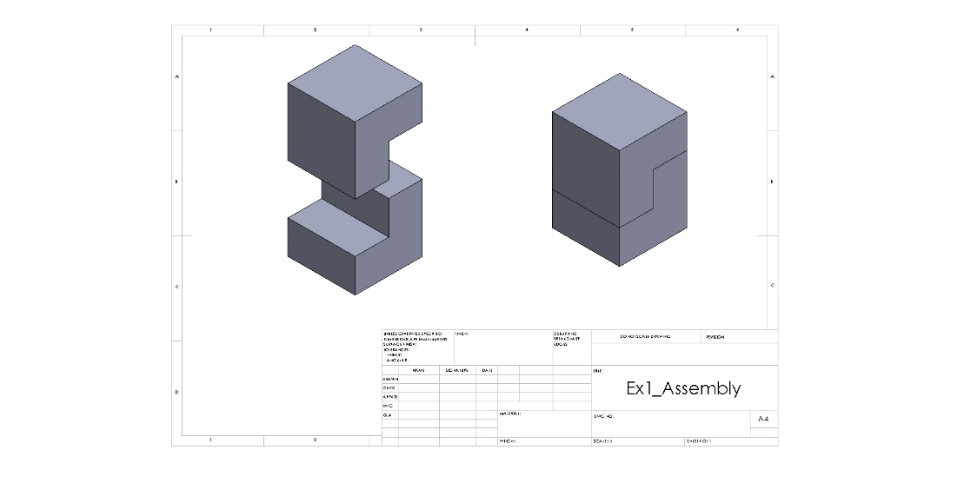

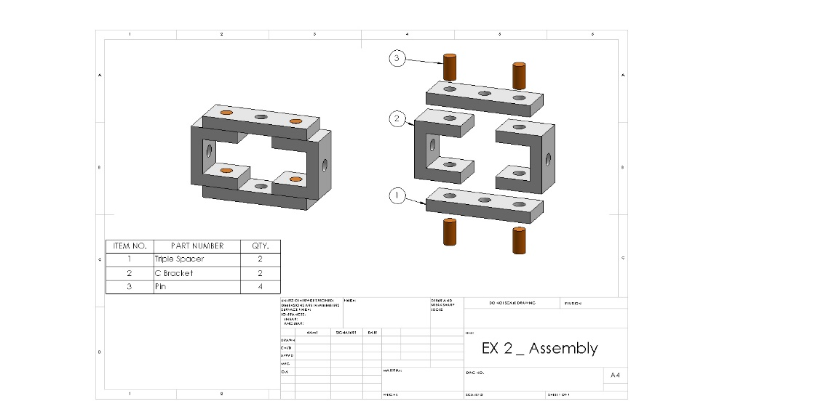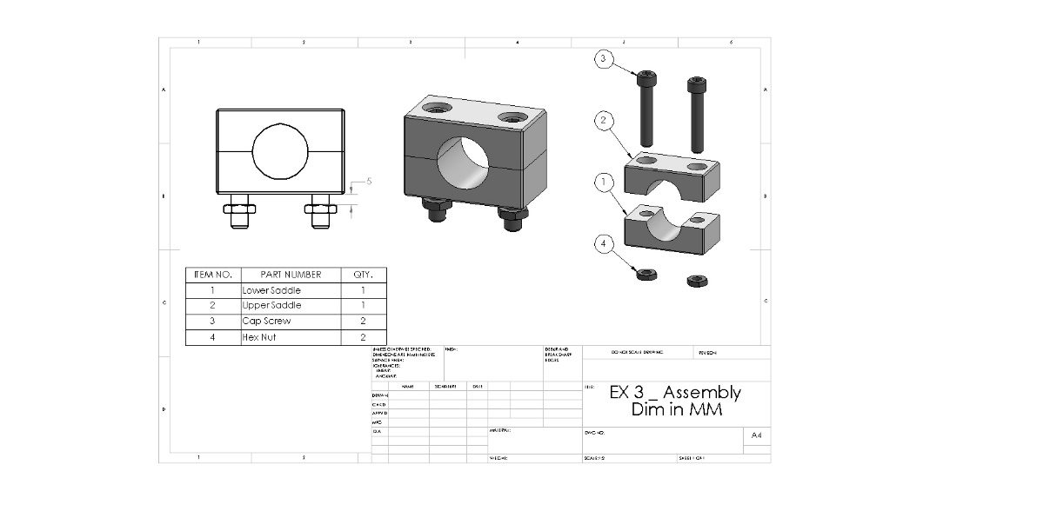

**TIP: Find random object around you and try modeling and assembling them as well ;)**